Integrated framework for educational material

development based on linked data supporting learning analytics

Ma Chenguang

February,2018

Master Course

*Computer Science*

*Graduate School of Information Science and Electrical Engineering*

Table of Contents

Chapter1 Introduction 5

1.1 Background 5

1.1.1 The development of e-learning 5

1.1.2 The development of LMS and electronic educational material supporting learning analytics 5

1.1.3 IoT and IoT security issue 6

1.2 Research Objectives 7

1.3 Significance of this thesis 8

1.4 Thesis Outline 9

Chapter2 Related works and Research methodology 11

2.1 Research on contents of IoT security based on Linked data 11

2.1.1 Research on contents of IoT security 11

2.1.2 E-content for education and Linked Data 12

2.1.3 RDF (Resource Description Framework) 13

2.2 Research on technology for e-Learning system with learning analytics 15

2.2.1 ePub format and ePub.js 15

2.2.2 Log data extraction, storage and analytics 18

2.2.3 Visualization tool of log data for learning analytics 19

2.3 Final Conclusion 20

Charpter3 Framework Design 21

3.1 Designation for digital material contents of IoT security based on Linked Data 21

3.1.1 RDF schema’s design 21

3.1.2 Instance example design 22

3.1.3 Prefix design 23

3.2 Designation for authoring tool based on RDF store 23

3.3 Designation ePub format e-Book based on authoring tool 24

3.4 Designation web-based viewer for ePub format e-Book with learning analytics 26

3.5 Designation of visualization of reading log data 27

Chapter4 Framework Implementation 30

4.1 Implementation of authoring tool with efficient multimedia contents of IoT security material 30

4.1.1 RDF store for IoT security 30

4.1.2 Authoring tool 32

4.2 Implementation of ePub web viewer with learning analytics 33

Chapter5 Discussion 35

5.1 The discussion for efficiency and convenience of material development framework 35

5.2 The discussion for capability of optimizing the materials basing on obtaining the feedback from students 39

Chapter6 Conclusion and Future work 40

ACKNOWLEDGEMENT 41

REFERENCE 42

Figure 1: Cloud of Linked Data [21]. 13

Figure 2: Classes and Resources as Sets and Elements [26]. 14

Figure 3: Class hierarchy for RDF Schema [27]. 15

Figure 4: The architecture epub [28]. 16

Figure 5: BookRoll. 18

Figure 6: Parallel Coordinates from D3.js examples(left) and Parallel Coordinates version of Time-tunnel(right). 19

Figure 7: Gantt Chart from Wikipedia (left) and Cubic Gantt Chart (right). 20

Figure 8: An example of RDF store schema. 22

Figure 9: Designation of RDF skeleton of IoT security. 22

Figure 10: Designation of a new prefix for IoT security. 23

Figure 11: Designation of a new prefix for IoT security. 23

Figure 12: The utilization of RDF store. 24

Figure 13: Overview of authoring tool [8]. 24

Figure 14: The component of ePub format book. 26

Figure 15: The conceptual overview of web-based viewer realized by utilizing the Epub.js. 27

Figure 16: The architecture of designation for learning analytics. 27

Figure 17: Cubic Gantt Chart [35], perspective view (left) and orthogonal view (right). 28

Figure 18: BookLooper data of 12th, Nov., 2014 in 3D mode(left) and BookLooper data of 12th and 19th, Nov., 2014 on two Data-wings overlapped together(right). 29

Figure 19: Exported RDF file of IoT security. 30

Figure 20: Management of RDF data of IoT security by virtuoso. 31

Figure 21: Storage of RDF file. 31

Figure 22: Retrieval of RDF file. 32

Figure 23: The implement of authoring tool system for IoT security. 32

Figure 24: The implement of web viewer for ePub format digital book based on ePub.js. 33

Figure 25: The implement of architecture for reading log data extraction. 34

Figure 26: The RDF schema for Japanese history. 35

Figure 27: The design for RDF data of Japanese history. 36

Figure 28: The RDF data of Japanese history. 36

Figure 29: The implement of storage for RDF data of Japanese history. 37

Figure 30: The implement of query for RDF data of Japanese history by SPARQL. 37

Figure 31: The implement of authoring tool for Japanese history. 38

Figure 32: The implement of searching for Japanese history information. 38

# Chapter1 Introduction

This chapter introduces the background of this thesis and declares the contribution of this study on educational material development.

## 1.1 Background

### 1.1.1 The development of e-learning

With the current technological explosion, the arrival of Web 2.0 and the growth of ICT (information communication technology), e-learning play an important role in higher education. As the same time, a developing infrastructure to support e-learning within education includes repositories, or digital libraries, to manage access to e-learning materials, consensus on technical standardization, and methods for peer review of these resources.

E-learning is the use of Internet technologies to enhance knowledge and performance. Innovations in e-learning technologies point toward a revolution in education, allowing learning to be individualized (adaptive learning), enhancing learners’ interactions with others (collaborative learning), and transforming the role of the teacher.

E-learning technologies offer learners control over content, learning sequence, pace of learning, time, and often media, allowing them to tailor their experiences to meet their personal learning objectives. In diverse field education contexts, e-learning appears to be at least as effective as traditional instructor-led methods such as lectures. Students do not see e-learning as replacing traditional instructor-led training but as a complement to it, forming part of a blended-learning strategy.

Meanwhile, educators will no longer serve mainly as the distributors of content, but will become more involved as facilitators as well as assessors of learning activities.[1]

### 1.1.2 The development of LMS and electronic educational material supporting learning analytics

With the development of e-learning, the appearance of so-called Learning Management Systems (LMSs) allowed certain tasks related to learning analytics to be technologically. Learning analytics seek to enhance the learning processes through systematic measurements of learning related data and to provide informative feedback to learners and teachers. A course in learning system is created for each lecture course, and attendance, quizzes, distribution of materials, submission of reports, surveys, and other materials are handled digitally. Above that, track data from learning management systems (LMS) constitute a main data source for learning analytics. Using a dynamic, longitudinal perspective, computer-assisted formative assessments seem to be the best predictor for detecting underperforming students and academic performance.[2]

To improve teaching and learning, Kyushu University has adopted an approach called Bring Your Own Personal Computers (BYOPC) for all the students and it provides broad-band and high-speed wireless Internet access in the entire campus.

In addition, Kyushu University introduced a single platform learning system (Mitsuba, M2B) that was constructed from common learning management system (Moodle), an e-portfolio system (Mahara), and an e-book system (BookRoll). BookRoll, which can record students learning behaviors when they use e-books to read learning contents[3]. Users can read, go to next, and return to previous. They can also make bookmarks and leave memos. Students accumulate knowledge by reading the e-books. The learning logs that students left are defined as the Accumulation of Knowledge Logs (AKLog). However, the current e-books are only support pdf format file. Research studies show that multimedia educational materials promote a higher motivation and efficiency for students' learning activities. For instance, the study which investigates on the learning impact of utilizing Wikipedia's community in education shows that participation in a cyber-community exposes students to a new culture and netiquette, to a set of explicit and tacit rules and cultural norms[4]. This requires students to internalize the embedded online culture in order to join the community, a form of acculturation which may cause stress, but which can lead to opportunities for growth, learning and development. The formation of a virtual learning community through the procedural and structural coupling of two discrete activity systems opens a new space for participatory learning.[4]In addition, a study of case teaching indicates that YouTube videos can be a valuable source of content to supplement existing case teaching materials.[5]

### 1.1.3 IoT and IoT security issue

In recent year, the Internet of Things (IoT) has drawn significant research attention. IoT is considered as a part of the Internet of the future and will comprise billions of intelligent communicating 'things'. The future of the Internet will consist of connected all kinds of devices ,so that it will blur the borders of the world with physical entities and virtual components. [6]

The exponential growth of these devices in a communicating–actuating network facilitate the blend between sensors and actuators with the environment around us seamlessly. Thereby, the information sharing across platforms in order to empower the connected things with new capabilities which are able to comfort and facilitate the whole fields by measuring, inferring and understanding environmental indicators.

In this scenario, the satisfaction of security and privacy requirements plays a fundamental role. Such requirements include data confidentiality and authentication, access control within the IoT network, privacy and trust among users and things, and the enforcement of security and privacy policies. Traditional security countermeasures cannot be directly applied to IoT technologies due to the different standards and communication stacks involved. Accordingly, there are great amount researchers are focus on the research about IoT security.

Furthermore, there is an international project titled “Security in the Internet of Things Space” between IIT Delhi and Kyushu University aim to build secure IoT space. In this project, we aim to achieve secured IoT space by working out training and education to use IoT space safely for both people who provide IoT space service and who use its service. [7]

Therefore, with a long-term point of view, it is necessary for the developers and users to learn more about the new technology and knowledge related to deal with the IoT security threats in such a dynamic environment.

## 1.2 Research Objectives

With the development of e-learning, the manufacture of contents, electronic　educational materials with high quality in multimedia format, has become especially difficult and significant. The research object is to develop educational material development framework based on linked data supporting learning analytics. In addition, IoT security has become more and more significant, we choose the IoT security as one target for framework.

There are four detailed research objectives in this thesis summarized as following:

In the first step, it is supposed to development a special database for storing the educational contents of information (based on Linked Data), IoT threat information, into the RDF (Resource Description) store. If a database is built based on Linked Data, it becomes easy to update in terms of its contents and to share them easily with other researchers/educators. As well, it facilitates the accessible flexibility when other applications are eager to utilize the contents based on Linked Data stored in the RDF stores.

In the second step, it is to provide an authoring tool that enables professors/teachers to easily develop educational materials about IoT security using the database realized as Linked Data. A prototype system [8] has been developed by Takubo etc. and currently it is supposed to adjust it to specific information, IoT threat information, with original and specific layout and the information presentation included Wikipedia and YouTube video.

In the third step, the sematic information and knowledge generated by authoring tool is supposed to be edited and punished to the ePub format as educational materials which are capable to be viewed by students.

In the fourth step, a ePub web-based educational material viewer that has learning analytics functionality is developed, for that, a dedicated web-based viewer is necessary. By utilizing and modifying the ePub.js, the web-based educational material viewer with the functionality for collecting learning activity data is able to be developed. After that, by visualizing their learning activity data collected from web-based viewer with some visualization tools, learning analytics for analyzing the students' learning manners is capable to be conducted.

## 1.3 Significance of this thesis

The significance of this thesis is that we proposed an educational material development framework based on linked data supporting learning analytics to develop the educational material efficiently.

The detailed significance of this research work is summarized as:

1. Educational material contents development based on the Linked data technology has been implemented. Actually, there is little educational material in the world related to IoT security. Through the establishment of data base based on linked data, a sematic data network has been constructed which is easily accessed and utilized.[9]
2. Educational material authoring tool based on linked data with Wikipedia, YouTube, image information as well has been rebuilt. Thereby, teachers who are not familiar with computer science and programing skills are capable to develop multimedia educational materials with highly educational efficiency easily. [10]
3. EPub format material development with pagination information for supporting learning analytics by utilizing the ePub CFIS (Canonical Fragment Identifiers) [11, 12] specification has been realized. This thesis attempts to rectify educational materials composition published as ePub format by defining an arbitrary structural reference that can uniquely identify any location, or simple range of locations.
4. An ePub web-based educational material viewer supporting learning analytics has already been accomplished. [13] While students reading the educational material, their reading log data is able to be recorded. After visualizing the log data of reading activity by visualization tools, the learning status of student are easily to be learn about and then, teachers are able to modify the educational material or giving the personalized instruction for students basing the result of visualization.

## 1.4 Thesis Outline

In this paper, we propose a learning analytics framework for IoT security education as an integration with the authoring tool based on Linked Data, the web-based material viewer supporting learning analytics and visualization tools for learning analytics.

This thesis consists of six chapters. The remainder of this thesis is structured as follows:

Chapter 2

This chapter describes the related works of this thesis. Relevant research on e-contents for education basing on linked data. Meanwhile, the technology of ePub publish and the ePub web-based viewer implementation are introduced. After that, the data and learning analytics on education are indicated. Above all, I propose a framework for educational material development supporting learning analytics.

Chapter 3

This chapter mainly describes the system design. Designation for digital material contents of IoT security based on Linked Data, authoring tool based on RDF store, ePub format e-Book based on authoring tool, web-based viewer for ePub format e-Book with learning analytics are detailed description. Meanwhile, the visualization method for the learning data generated from web-based viewer.

Chapter 4

In this chapter, the implementation result of framework is shown. Furthermore, it detailed the RDF store for IoT security and the utilization method of data stored in the store. In addition, educational material authoring tool and ePub web-based viewer interface supporting learning analytics are shown. Reading learning logs generated from web-based viewer are listed as well.

Chapter 5

The preliminary evaluation of the framework is discussed in this chapter. It includes the summary of this thesis as well.

Chapter 6

This chapter sketches out scope for further research.

# Chapter2 Related works and Research methodology

## 2.1 Research on contents of IoT security based on Linked data

### 2.1.1 Research on contents of IoT security

During the last decade, Internet of Things (IoT) approached our lives silently and gradually, thanks to the availability of wireless communication systems (e.g., RFID, WiFi), which have been increasingly employed as technology driver for crucial smart monitoring and control applications [14,15].

Nowadays, the concept of IoT is many-folded, it embraces many different technologies, services, and standards and it is widely perceived as the angular stone of the ICT market in the next ten years [16]. From a logical viewpoint, an IoT system can be depicted as a collection of smart devices that interact on a collaborative basis to fulfill a common goal. At the technological floor, IoT deployments may adopt different processing and communication architectures, technologies, and design methodologies, based on their target. For instance, the same IoT system could leverage the capabilities of a wireless sensor network (WSN) that collects the environmental information in a given area and a set of smartphones on top of which monitoring applications run. In the middle, a standardized or proprietary middleware could be employed to ease the access to virtualized resources and services. The middleware, in turn, might be implemented using cloud technologies, centralized overlays, or peer to peer systems [17].

Of course, this high level of heterogeneity, coupled to the wide scale of IoT systems, is expected to magnify security threats of the current Internet, which is being increasingly used to let interact humans, machines, and robots, in any combination. More in details, traditional security countermeasures and privacy enforcement cannot be directly applied to IoT technologies due to their limited computing power, more over the high number of interconnected devices arises scalability issues.

At the same time, to reach a full acceptance by users it is mandatory to define valid security, privacy and trust models suitable for the IoT application context [18]. With reference to security, data anonymity, confidentiality and integrity need to be guaranteed, as well as authentication and authorization mechanisms in order to prevent unauthorized users (i.e., humans and devices) to access the system.

Whereas, concerning privacy requirement, both data protection and user personal information confidentiality have to be ensured, since devices may manage sensitive information (e.g. user habits). Finally, trust is a fundamental issue since the IoT environment is characterized by different devices which have to process and handle the data in compliance with user needs and rights.

Above all, the educational contents for IoT security play a key role, which facilitate the users are able to face normal and unexpected changes of the IoT environment. Accordingly, education on privacy and security issues should be treated as a significant part in the educational field. Meanwhile, the educational contents of IoT security for cultivating the students is not enough in the e-learning network.

Accordingly, the development for the educational contents of IoT security has become an important issue.

### 2.1.2 E-content for education and Linked Data

In recent years, e-learning has been regarded as a developing research. However, making electronic educational materials is different from other e-learning activities for its involvement of precise information retrieval, systematic knowledge management, and pedagogical process. These features make educational material development systems more complicated than basic web-based information systems, which consequently need integrated solutions to address those issues together, especially when multimedia education resources are more and more popular.

As educational material developers have experienced on the Internet, finding the right information in a specifically professional field is not an easy thing, and finding multimedia resources which are semantically relevant to requests is even harder. The limitation of HTML in information representation is that HTML was designed to represent human readable literal information rather than carrying machine readable semantic information of literal and multimedia resources. In a practical educational material development scenario, the information and knowledge update frequently, because educational material developers naturally treat an electronic material development system as a more organized information and knowledge base rather than a massive global network. Towards resolving this problem, we utilize a semantic knowledge management-data model, linked data, to facilitate the information and knowledge integration in educational material development environments, and to bridge the external public resource store and the internal knowledge base.

Berners-Lee coined the term Linked Data describing a set of best practices for publishing and connecting structured data on the Web [19,20]. As shown in Fig.1, these practices are the foundation of the evolution of the Web of Documents to the Web of Data, a global data space connecting data from a multitude of different domains. In order to become part of a single global data space, Berners-Lee proposed a number of (technical) rules for publishing data on the Web that have become known as Linked Data Principles [19]:

1.Use URIs as names for things.

2.Use HTTP URIs so that people can look up those names.

3.When someone looks up a URI, provide useful information, using the standards (RDF, SPARQL).

4.Include links to other URIs, so that they can discover more things.

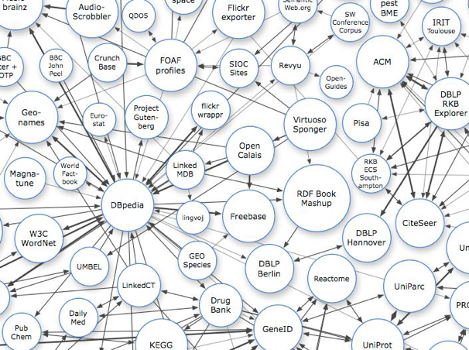

Figure 1: Cloud of Linked Data [21].

In summary, linked data is about data integration [21]. In the area of e-Learning, such data can be shared as learning objects (LO) or learning entities of any kind, respectively.

Dicheva identifies three generations of web-based educational systems [22]. The systems of the first generation provide a central entry-point for accessing learning materials and online course, e.g., LMS and educational portals. The systems of the second generation employ web and AI technologies to intelligently support personalization and adaption. Such systems are called educational adaptive hypermedia systems. The third generation of web-based educational systems is a class of ontology-aware software, using and enabling Semantic Web standards and technologies in order to grant scalability, reusability and interoperability of educational material that is distributed over the web. Therefore, Linked Data technologies raise high expectations with respect to providing solutions in a field like e-Learning.

### 2.1.3 RDF (Resource Description Framework)

Resource Description Framework (RDF) is a language for representing information (metadata) about resources in the World Wide Web. The resources are not limited to web pages but can also include things that can be identified on web. [23] RDF data is written in XML format, machine readable, and can be output by machines. However, it is not designed for being displayed to people or designed to be displayed on the web, but computers. By using RDF, information of IoT security on the web can be integrated. RDF can describe the relationship between resources, but it has ambiguity like XML. The RDF Schema (RDFS) is required to reduce the limitation [24].

RDF Schema is RDF's vocabulary description language. RDFS is a standard language to create ontology in RDF. The ontology will define the vocabulary of RDF documents in a specific domain and manage the hierarchical relationship between terms. The ontology also has rules for reasoning of hidden information in RDF. For retrieving rich and accurate query results, advanced retrieval schemes using both metadata and ontology are considered [25].

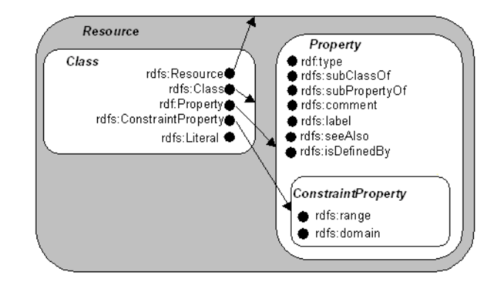

Figure 2: Classes and Resources as Sets and Elements [26].

As the RDF schema specification written, Fig.2 illustrates the concepts of class, subclass, and resource. A class is depicted by a rounded rectangle; a resource is depicted by a large dot. In the figure below, arrows are drawn from a resource to the class it defines. A subclass is shown by having a rounded rectangle (the subclass) completely enclosed by another (the superclass). If a resource is inside a class, then there exists either an explicit or implicit rdf:type property of that resource whose value is the resource defining the containing class. (These properties are shown as arcs in the directed labelled graph representation in Fig.3). The RDF resources depicted in Fig.2 are described either in the remainder of this specification, or in the RDF Model and Syntax specification.

Fig.3 shows the same information about the class hierarchy as in Fig.2, but does so using a “nodes and arcs" graph representation of the RDF data model. If one class is a subset of another, then there is an rdfs:subClassOf arc from the node representing the first class to the node representing the second. Similarly, if a resource is an instance of a class, then there is an rdf:type arc from the resource to the node representing the class. Not all such arcs are shown. We only show the arc to the most tightly encompassing class, and rely on the transitivity of the rdfs:subClassOf relation to provide the rest.” quoted from RDF schema specification.

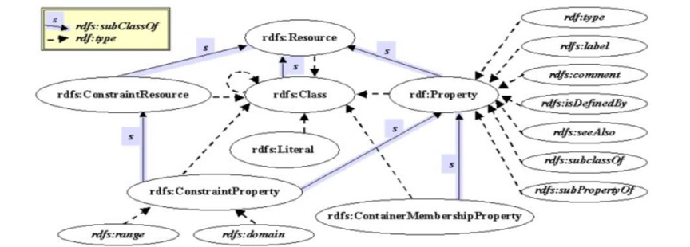

Figure 3: Class hierarchy for RDF Schema [27].

## 2.2 Research on technology for e-Learning system with learning analytics

### 2.2.1 ePub format and ePub.js

EPUB is an e-book file format with the extension .epub that can be downloaded and read on devices like smartphones, tablets, computers, or e-readers. It is a technical standard published by the International Digital Publishing Forum (IDPF). The term is short for electronic publication and is sometimes styled ePub. EPUB became an official standard of the IDPF in September 2007, superseding the older Open eBook standard. The Book Industry Study Group endorses EPUB 3 as the format of choice for packaging content and has stated that the global book publishing industry should rally around a single standard. EPUB is the most widely supported vendor-independent XML-based (as opposed to PDF) e-book format; that is, it is supported by the largest number of hardware readers.

The EPUB standard is a widely used and easily convertible format. Many books are currently in this format, and it is convertible to many other formats (such as PDF, Mobi and iBooks).

An unzipped ePUB3 is a collection of HTML5 files, CSS, images and other media – just like any other website. However, it enforces a schema of book components, which allows us to render a book and its parts based on a controlled vocabulary.

More specifically, the ePUB schema standardizes the table of contents, provides a manifest that enables the caching of the entire book, and separates the storage of the content from how it’s displayed. The reason why it shows the attractive performance is that it supports the following features:

1.Reflowable document: optimize text for a particular display

2.Fixed-layout content: pre-paginated content can be useful for certain kinds of highly designed content, such as illustrated books intended only for larger screens, such as tablets.

3.Like an HTML web site, the format supports inline raster and vector images, metadata, and CSS styling.

4.Page bookmarking

5.Passage highlighting and notes

6.A library that stores books and can be searched

7.Re-sizable fonts, and changeable text and background colors

8.Support for a subset of MathML

9.Digital rights management—can contain digital rights management (DRM) as an optional layer

Moreover, Epub.js is a JavaScript library for rendering ePub documents in the browser, across many devices.Epub.js provides an interface for common ebook functions (such as rendering, persistence and pagination) without the need to develop a dedicated application or plugin. Importantly, it has an incredibly permissive Free BSD license.

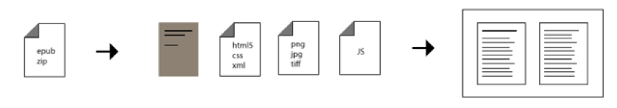

Figure 4: The architecture epub [28].

In addition, EPUB Canonical Fragment Identifier, defines a standardized method for referencing arbitrary content within an EPUB Publication through the use of fragment identifiers.

The Web has proven that the concept of hyperlinking is tremendously powerful, but EPUB Publications have been denied much of the benefit that hyperlinking makes possible because of the lack of a standardized scheme to link into them. Although proprietary schemes have been developed and implemented for individual Reading Systems, without a commonly-understood syntax there has been no way to achieve cross-platform interoperability. The functionality that can see significant benefit from breaking down this barrier.

Epubcfi attempts to rectify this situation by defining an arbitrary structural reference that can uniquely identify any location, or simple range of locations, in a Publication: the EPUB CFI. The following considerations have strongly influenced the design and scope of this scheme:

1.The mechanism used to reference content should be interoperable: references to a reading position created by one Reading System should be usable by another.

2.Document references to EPUB content should be enabled in the same way that existing hyperlinks enable references throughout the Web.

3.Each location in an EPUB file should be able to be identified without the need to modify the document.

4.All fragment identifiers that reference the same logical location should be equal when compared.

5.Comparison operations, including tests for sorting and comparison, should be able to be performed without accessing the referenced files.

6.Simple manipulations should be possible without access to the original files (e.g., given a reference deep in a file, it should be possible to generate a reference to the start of the file).

7.Identifier resolution should be reasonably efficient (e.g., processing of the first chapter is not required to resolve a fragment identifier that points to the last chapter).

8.References should be able to recover their target locations through parser variations and document revisions.

9.Expression of simple, contiguous ranges should be supported.

10.An extensible mechanism to accommodate future reference recovery heuristics should be provided.

A Canonical Fragment Identifier (CFI) is a similar construct to these, but expresses a location within an EPUB Publication. For example:

book.epub#epubcfi(/6/4[chap01ref]!/4[body01]/10[para05]/3:10)

The function-like string immediately following the hash (epubcfi(…)) indicates that this fragment identifier conforms to the scheme defined by this specification, and the value contained in the parentheses is the syntax used to reference the location within the specified Publication (demo.epub). Using the processing rules defined in Path Resolution, any Reading System can parse this syntax, open the corresponding Content Document in the Publication and load the specified location for the User.

### 2.2.2 Log data extraction, storage and analytics

According to Darrell et al [29], the use of online tools allows instructors to recognize students’ activities, for instance, how long they read wired electronic textbooks and how they understand the important parts of them. There is also the research about relationship between Self-Regulated Learning (SRL) and students’ learning behavior by using learning activities data [30]. Smart phones enable students to study through e-Learning materials anywhere and at any time. SCROLL is one of the effective e-Learning systems that use e-Learning activity data [31].

Our university employed e-books viewer called BookRoll [32] which users can read e-books registered into the service through the Internet. Users can access this service on any platform, in essence, any device and any OS. This service gathers users’ activity data of reading e-books, for example, how long each user reads an e-book, from and to which pages of the e-book the user traverse. The attributes of such data are date, time, user name, material name that the user access, activity as a sequence of reading page indices. As other functionalities of BookRoll, it is possible to add a marker to important places and write memo. By utilizing the BookRoll, it is possible to conduct data analytics for learning activities.

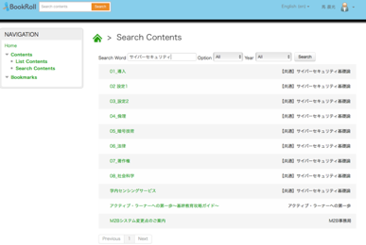

Figure 5: BookRoll.

Data analysis has become popular as one of the solutions for decision making since a decade ago. However, there is no guarantee that this always lead us to good solutions. Picciano et al [33] stated “As data-driven decision making has entered learning analytics era of the big data, these new approaches are not silver bullets while they may be the part of solution. Higher education administrators should employ them by evaluating whether they can be used in their institutions and by recognizing what roles they can play.”

Visualization of data is one of the ways to analyze them. Although the user can notice the new fact from visualization results of data, it may request us to use any statistical methods. However, it can be said that analysis by looking at the data enables the user to understand what the data mean more directly, in short, interactively and intuitively. Paul et al [34] insist a certain hypothesis for visualizing the multivariate data using multiple connected views. In this paper, we propose visualization of learning activity data as one of the learning analytics methods.

### 2.2.3 Visualization tool of log data for learning analytics

Two visualization tools for learning analytics [35,36] have been already proposed.

There have been many visualization tools so far [37]. For instance, Parallel Coordinates [38] and Gantt Chart [39]. Although the visualization of time-oriented data is not easy task, various visualization methods have been proposed so far [40].

**2.2.3.1Parallel Coordinates and Parallel Coordinates version of Time-tunnel**

Parallel Coordinates is one of the methods to visualize multidimensional data, proposed by Alfred Inselberg et al [38]. Parallel Coordinates has parallel multi poly-line in 2-D plane, which each line represents each attribute in data has properties as shown the right figure of Fig.6. Making the line chart by connecting vertices on each axis, the user can understand relationships among all attributes of each data. Parallel Coordinates may be the most suitable tool for visualizing multidimensional data or time-series numerical data similarly to line charts. However, there is a major problem that it is difficult to recognize each separated line in the case of huge data because many lines are overlapped together.

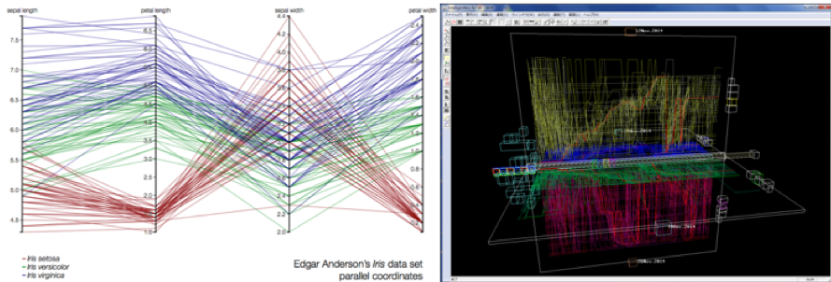

Figure 6: Parallel Coordinates from D3.js examples(left) and Parallel Coordinates version of Time-tunnel(right).

**2.2.3.2 Gantt Chart and Cubic Gantt Chart**

Gantt Chart proposed by Henry L. Gantt in 1910s is a kind of bar chart. It is well known as a project management tool. The left figure of Fig.7 shows a certain Gantt Chart. The vertical line represents a kind of job and the horizontal line represents time flow. Each job is illustrated by a rectangle. Left and right side of each rectangle are the start and end time of the corresponding job. This visualization allows users to understand the below at once:

1.What kind of activities there are

2.When each activity starts and end

3.How long each activity is

4.What activities overlap with other activities

5.How far the project goes

6.When the project starts and ends

Nakamura et al [36] had proposed a visualization tool called Cubic Gantt Chart for analyzing e-Learning activity data.

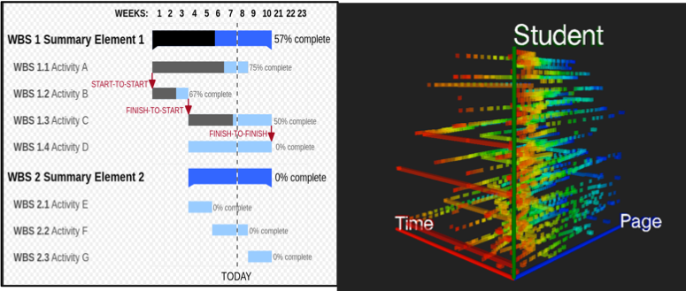

Figure 7: Gantt Chart from Wikipedia (left) and Cubic Gantt Chart (right).

## 2.3 Final Conclusion

With so much research done to develop the cut-edging technology regarding to IoT security, semantic web, ePub format publication, learning analytics and visualization, how to utilize the advanced the technology in supporting learning and teaching activity has become very necessary. Thereby, we propose the educational material development framework based on linked data supporting learning analytics to help teacher develop optimized multi-media material. By utilizing the ePub format web-based viewer supporting learning analytics, the learning activity log data is aimed to be obtained. Basing the visualization for reading log data, teachers are capable to learn about the learning status as feedback. In the following chapter, chapter three, the designation of framework is introduced.

# Charpter3 Framework Design

## 3.1 Designation for digital material contents of IoT security based on Linked Data

To achieve the RDF data of IoT security, there are three steps should be taken. Schema table, instance table, prefix table are supposed to be designed. In the Schema table, triples of conceptual design (schema) using RDFS and OWL are stored in the schema table. In the Instance table, table data entered mainly in Excel format or CSV format is saved in the form of an instance. By the utilization of prefix table, the definition of the namespace to be used.

### 3.1.1 RDF schema’s design

As the conclusion mentioned, there are three steps in designing the linked data for IoT security we are following. In the first step, we designed the schema of RDF store. An example of RDF store schema is shown in Fig.8. Meanwhile, IoT security information contains the followings.

1. What kinds of IoT (systems, devices, sensors) would be present in a Smart Building/Smart Home.

2. What kinds of attacks can be perpetrated on such IoT spaces.

3. What kinds of preventive measures can be taken to thwart such attacks.

4. What kinds of damages could be caused by such attacks and what would be the associated cost.

5.Textual explanation of IoT threats information.

6.Illustrated explanation of IoT threats information.

7.Video explanation of IoT threats information.

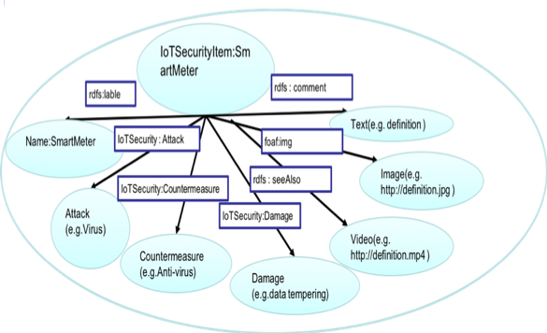

Figure 8: An example of RDF store schema.

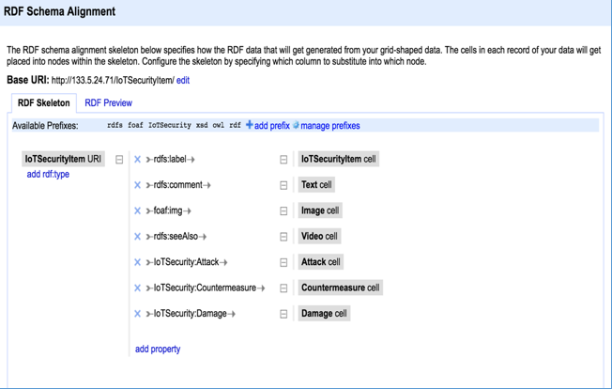

Figure 9: Designation of RDF skeleton of IoT security.

### 3.1.2 Instance example design

In the second step, excel file of IoT security is created according to the schema. It is supposed that knowledge management are based on a huge amount papers and resource in the internet. In the Fig.10, three instances example related to Smart Meter, HERMS, and Smart Speaker are showed.

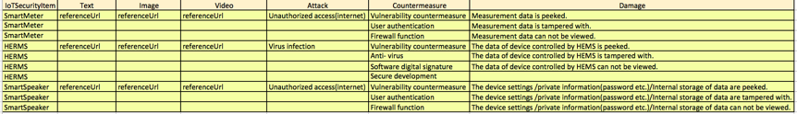

Figure 10: Designation of a new prefix for IoT security.

### 3.1.3 Prefix design

As the Figure shows, we designed a new prefix for IoT security, because there is no existed prefix for IoT security field according to the RDF schema document before it was been designed.

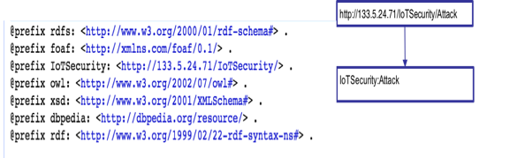

Figure 11: Designation of a new prefix for IoT security.

## 3.2 Designation for authoring tool based on RDF store

Basing the RDF database, useful web applications are easy to be developed. By access the RDF store, the triple stored in the database are able to be utilized.Fig.12 shows the overview of our authoring tool and Fig.13 shows the screen image of the prototype system of the authoring tool [8]. By specifying a keyword ‘Smart Meter’ (IoT device name) as the target of an educational material, the system retrieves text data, image data, video data, attack information, countermeasure strategy, damage information caused by attack related to the keyword from RDF stores. In this way, by using the authoring tool, educational material developers are able to edit the contents of the material regarding IoT security knowledge managed in RDF stores easily and efficiently.

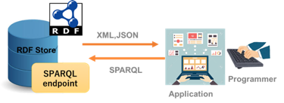

Figure 12: The utilization of RDF store.

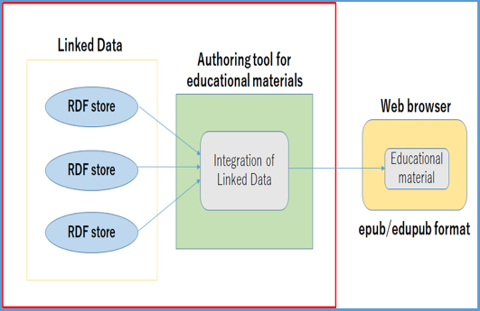

Figure 13: Overview of authoring tool [8].

## 3.3 Designation ePub format e-Book based on authoring tool

After achieving the authoring of IoT security educational materials, such educational materials are supposed to be shown as readable format like epub/edupub that facilitates the knowledge of IoT security to be learned on the Web. By authoring tool, the html file components are easy to obtain which is used for building ePub format digital materials. By utilizing the ePub builder tools, for instance, iBook author or Epub builder, the ePub format e-Book are able to be edited. As the Fig.14 shows that, an ePub format digital book components of IoT security are supposed to be built.

However, to realize the learning analytics for the page turning, we are supposed to design the ePub format educational material basing on ePub CFI specification, which is to define an arbitrary structural reference that can uniquely identify any location, or simple range of locations. Accordingly, the designation of path resolution is necessary. The steps are shown as following:

1.Step Reference to Child Node (/)

A step with a slash (/) followed by an integer refers to a child node or nodes in the following manner:

1-1Each element is assigned an even positive index.

1-2Each (possibly empty) collection of non-element nodes before the first element, between elements, and after the last element are given odd indices according to their position (these typically refer to the text of the Publication).

1-3Non-element nodes that are not text nodes are always ignored.

For a Standard EPUB CFI, the leading step in the CFI must start with a slash (/) followed by an even number that references the spine child element of the Package Document's root package element. The Package Document traversed by the CFI must be the one specified as the default rendition in the Publication's META-INF/container.xml file.

2.XML ID Assertion ([)

When an EPUB CFI references an element that contains an ID [XML], the corresponding path step must include that ID in square brackets (i.e., after the slash (/) and even number that identifies the element).

Specification of identifiers adds robustness to the CFI scheme: Reading System may determine that the location referenced by the CFI is not the original intended location, and may use the identifier to compute the set of steps that reach the desired destination in the content (see Intended Target Location Correction). The cost of this added robustness is that comparison (and sorting) of CFI strings may be performed only after logically stripping all bracketed substrings.

3.Step Indirection (!)

A step with a leading exclamation point (!) indicates that the reference must be followed and the next step applied starting from the new target node (or root element node when a complete XML document is referenced).Only the following references are honored:For itemref in the Package Document spine, the reference is defined by the href attribute of the corresponding item element in the manifest (i.e., that the itemref's idref attribute references). For [HTML5] iframe and embed elements, references are defined by the src attribute.For the [HTML5] object element, the reference is defined by the data attribute. For [SVG] image and use elements, references are defined by the xlink:href attribute.

4.Terminating Step – Character Offset (:)

A terminating step with a leading colon (:) followed by an integer refers to a character offset. The given character offset may apply to an element node only if this element is the [HTML5] img element with an alt attribute containing the text to which the character offset applies.

For text nodes, the offset is zero-based and always refers to a position between characters, so 0 means before the first character and a number equal to the total UTF-16 length means after the last character. A character offset value greater than the UTF-16 length of the available text must not be specified. A character offset terminating step may be present only following a /N step. For XHTML Content Documents, N would be an even number when referencing the alt text of an img element, and N would be odd when referencing text in a text node.

No other steps may follow a character offset terminating step.

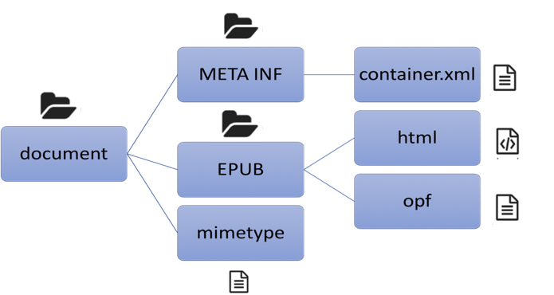

Figure 14: The component of ePub format book.

## 3.4 Designation web-based viewer for ePub format e-Book with learning analytics

To realize the web-based viewer for ePub format e-Book with learning analytics, there are two steps are supposed to be applied. At the first step, by utilizing the ePub.js, web-based viewer is able to be implemented. User are easy read ePub format material without the limitation of devices. At the second step, the reading log data are required to be recorded. By utilizing the recorded reading log data, learning analytic is able to be conducted, so that for the teacher, it is easy to make a good sense about learning and reading condition of students. Fig.15 is the conceptual overview of web-based viewer realized by utilizing the Epub.js. By access the URL, students are able to read the ePub Format book on web. The architecture of designation for learning analytics is shown as Fig.16.

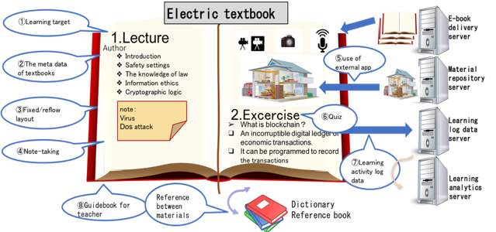

Figure 15: The conceptual overview of web-based viewer realized by utilizing the Epub.js.

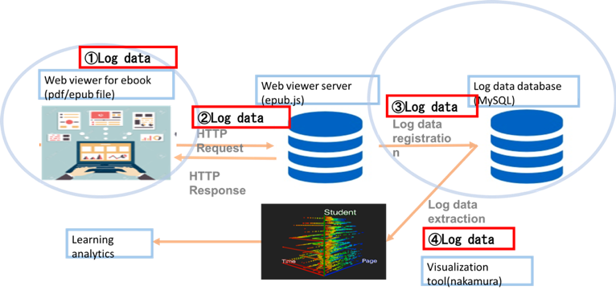

Figure 16: The architecture of designation for learning analytics.

## 3.5 Designation of visualization of reading log data

For realizing the learning analytics, the reading log data can be generated from web-based viewer is supposed to be imported into the visualization tools has been promoted [35,36] which are mentioned as chapter2.

One visualization tool called Cubic Gantt Chart uses a 3D space so that it can treat three attributes, one additional property besides two features of the standard Gantt Chart, each of those is assigned to each X, Y and Z axes of the 3D space, respectively. We allotted time, each student and each index of ePub format materials to X, Y, and Z-axes as shown in Fig. 17. Fig. 17 is learning activity data of information technology class collected by BookLooper from October 2014 to January 2015.

In the right figure of Fig. 12, by looking at the tool in the direction towards any face, the user can understand relationships between the corresponding two attributes of the data, e.g., page indices of the material and reading times. From the figure, it can be seen that some students looked at the ending pages for long time at the beginning of the lecture. By checking the reading times, most students took the same action at an early time because of color depth, and some students gradually spend time to early page and some students spend time towards ending pages. Also, some students looked at the first page for a long time. They may hardly listen to the teacher or they may be asleep just after opening their textbook in this lecture. Students reading the ending page at early time may do homework assigned in this lecture. The areas of sky bluish voxels and yellowish voxels have deep color at middle time of this lecture so it can be said that at that time, almost students read the pages of sky bluish or yellowish colors many times.

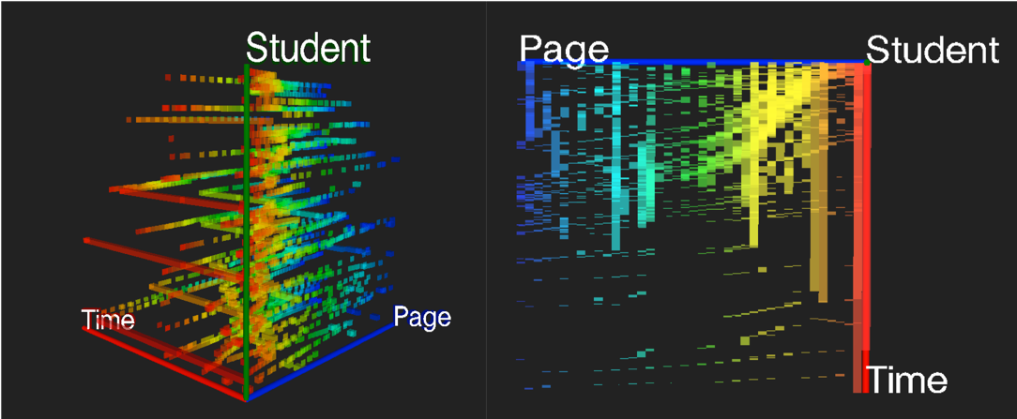

Figure 17: Cubic Gantt Chart [35], perspective view (left) and orthogonal view (right).

The other visualization tool called Parallel Coordinates version of Time-tunnel [36] and applied it for analyzing e-Learning activity data. Fig. 18 shows two screen images as visualization results of the tool. The left figure of Fig. 18 is a bird eye view of the data for 12th, Nov. in 2014 in 3D mode. In this figure, each chart represents one student learning activity data and their total number is 80. The vertical axis means page numbers of an e-Learning material and the horizontal axis means number of times. It is possible to highlight one of the charts as red color by specifying a student number. From this visualization result, it can be said that the most students took almost the same learning activity patterns like the red chart, which means the students looked at one page by one page sequentially maybe according to the teacher’s talk. This pattern becomes unstable after the two-third of the total time. It may be because of a pause in the lecture at this time and the students started their exercises themselves. The other students who did not take this pattern may be the ones the teacher should pay his/her attention. For instance, some students stopped changing pages on the way.

Moreover, the right figure of Fig. 18 shows the visualization of BookLooper data for 12th and 19th, Nov., 2014 on two Data-wings overlapped together in yellow color and blue color, respectively. From this visualization result, it is possible to understand the two learning activity pattern of the same students of 12th and 19th are very similar and the teaching patterns are also similar.

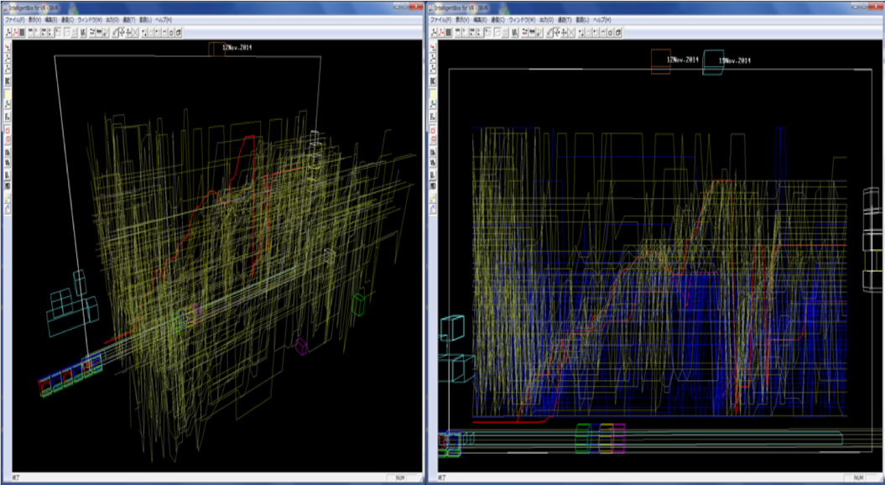

Figure 18: BookLooper data of 12th, Nov., 2014 in 3D mode(left) and BookLooper data of 12th and 19th, Nov., 2014 on two Data-wings overlapped together(right).

We are going to asked students to read the ePub format book by web-based viewer, and then their reading log data are expected to be obtained.

# Chapter4 Framework Implementation

## 4.1 Implementation of authoring tool with efficient multimedia contents of IoT security material

### 4.1.1 RDF store for IoT security

As mentioned in chapter3, IoT security information contains the seven character information for each of entity, What kinds of IoT (systems, devices, sensors) would be present in a Smart Building/Smart Home, what kinds of attacks can be perpetrated on such IoT spaces; what kinds of preventive measures can be taken to thwart such attacks; what kinds of damages could be caused by such attacks and what would be the associated cost; textual explanation of IoT threats information; illustrated explanation of IoT threats information; video explanation of IoT threats information. Finally, we created the original linked data file for IoT security basing on the excel file of IoT security was created according to the RDF schema. Fig.19 is the exported RDF file of IoT security by utilizing OpenRefine, a free, open source, power tool for working with messy data.

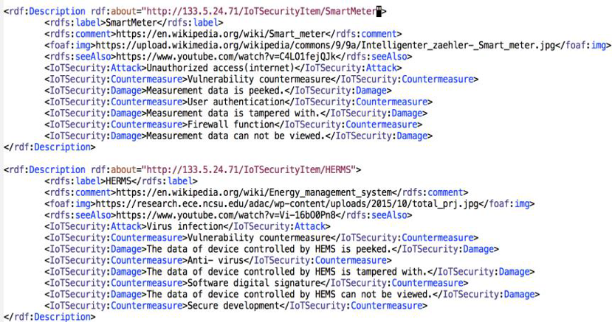

Figure 19: Exported RDF file of IoT security.

Basing the linked data designation, the management of RDF data is capable to be complied by virtuoso. The user interface of virtuoso is shown as Fig.20, which is a RDF data store constructed basing on Jena framework for managing, accessing, utilizing the RDF data. First of all, RDF data file is demanded to be imported(Fig.21). After that, RDF query function is capable to be achieved by SPARQL, a specific query language for RDF data base(Fig.22). As the Fig.22 shows that information of IoT security defined by us previously is obtained.

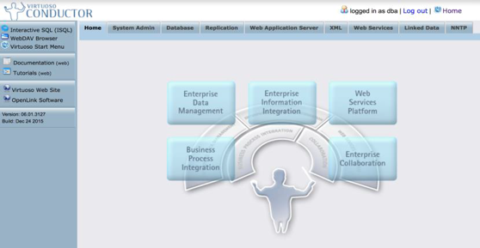

Figure 20: Management of RDF data of IoT security by virtuoso.

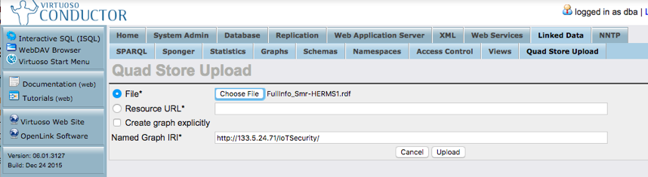

Figure 21: Storage of RDF file.

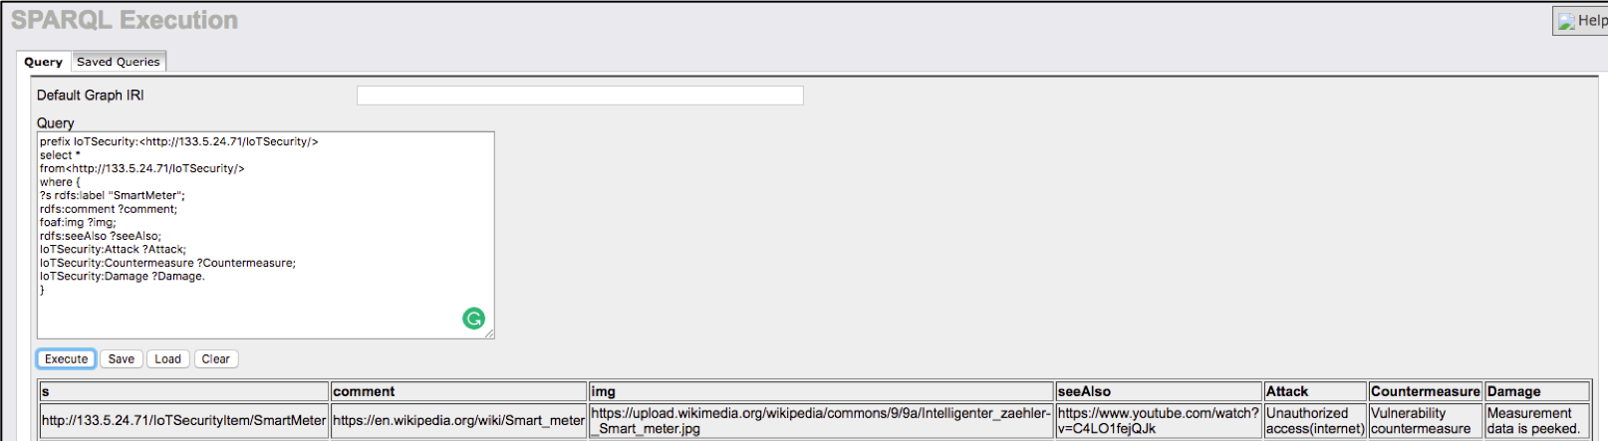

Figure 22: Retrieval of RDF file.

### 4.1.2 Authoring tool

After acquiring the digital educational contents data based on linked data, the contents are able to be show and edit by utilizing the authoring tool. Fig.23 shows the screen image of complemented system of the authoring tool for IoT security. By specifying a keyword ‘SmartMeter’ (IoT device name) as the target of an educational material, the system retrieves text data, image data and video data related to the keyword from RDF stores.

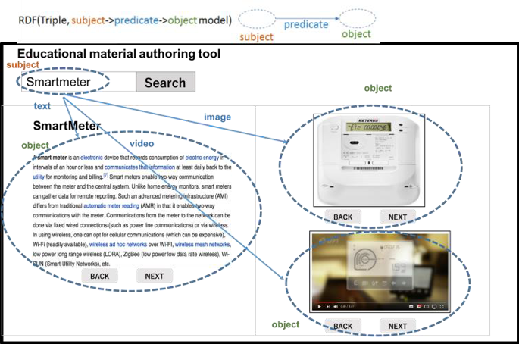

Figure 23: The implement of authoring tool system for IoT security.

## 4.2 Implementation of ePub web viewer with learning analytics

Frist of all, an e-book related to IoT security is compiled by iBook author which is a epub format material editor. Furthermore, aiming to keep track of the current reading position consists in storing the ePub CFI of the first visible element in the current viewport, the ePub files are recompiled according to ePub CFI specification. After that, web-based viewer(Fig.24) for ePub format educational materials which is designed originally was implemented by utilizing the ePub.js.

Thereby, students are capable to read the digital education materials which are designed and distributed by teachers. While student push the next button or previous button for turning the page of book, three type of reading log data are capable to be recorded and stored into the MySQL database. More specifically, the reading log data included student ID which is the identification of students, page information of e-Book that student is viewing, and system time when the pushing action occurred. The architecture of implement for reading log data extraction is shown as Fig.25. Furthermore, the recorded log data for learning log data stored in the database was able to be exported as csv format file.

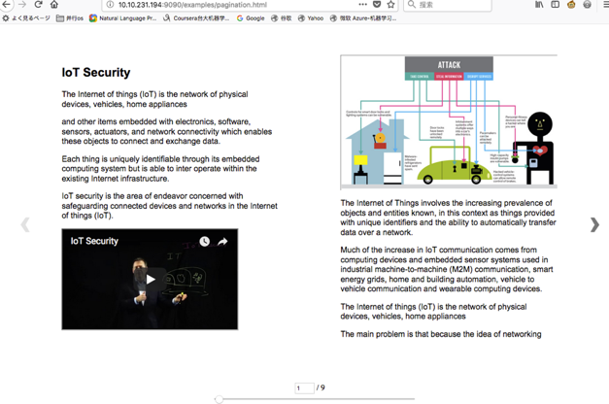

Figure 24: The implement of web viewer for ePub format digital book based on ePub.js.

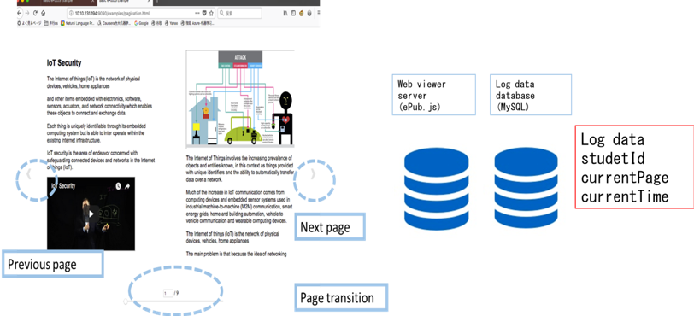

Figure 25: The implement of architecture for reading log data extraction.

# Chapter5 Discussion

The preliminary evaluation experiment was conducted to evaluate whether the framework is helpful for teachers to edit multimedia educational materials efficiently and conveniently. In addition, the evaluation experiment was conducted to evaluate whether the framework is useful for teachers to grasp students reading situation and optimize the materials. The following processes are conducted and evaluated in the evaluation experiment.

## 5.1 The discussion for efficiency and convenience of material development framework

We applied the material development framework to develop Japanese history educational contents. The conducted processes are shown as following.

In the first step, we design the RDF schema for linked data of Japanese history. It is showed as Fig.26.

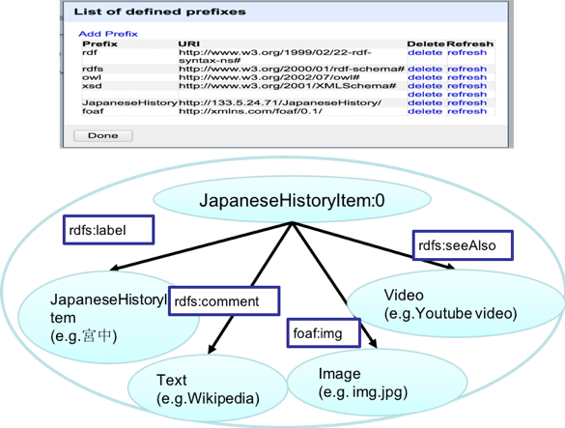

Figure 26: The RDF schema for Japanese history.

In the second step, the RDF data was supposed to be edited according to designed schema(Fig.27).

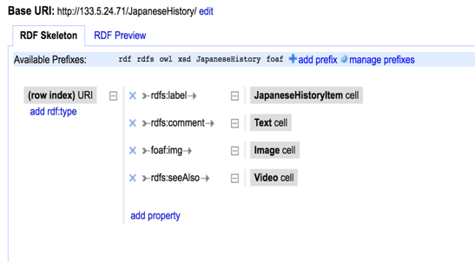

Figure 27: The design for RDF data of Japanese history.

In the third step, designed the RDF data was capable to be exported from Open Refine and imported into the Virtuoso. (Fig.28 and Fig.29) Accordingly, RDF data is able to be queried by utilizing query language SPARQL. (Fig.30)

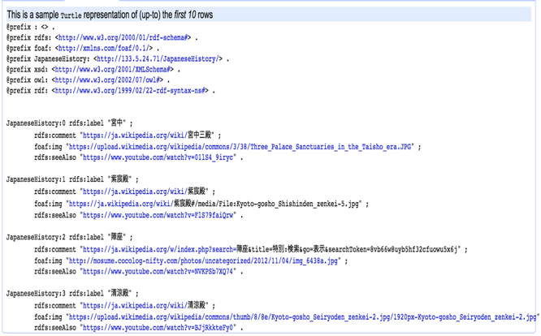

Figure 28: The RDF data of Japanese history.

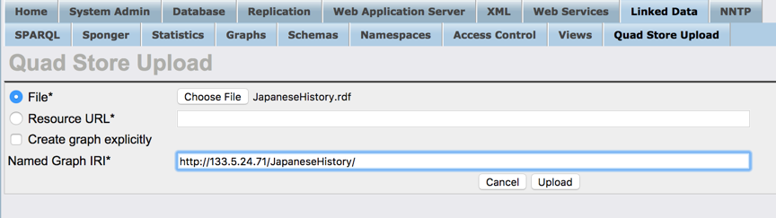

Figure 29: The implement of storage for RDF data of Japanese history.

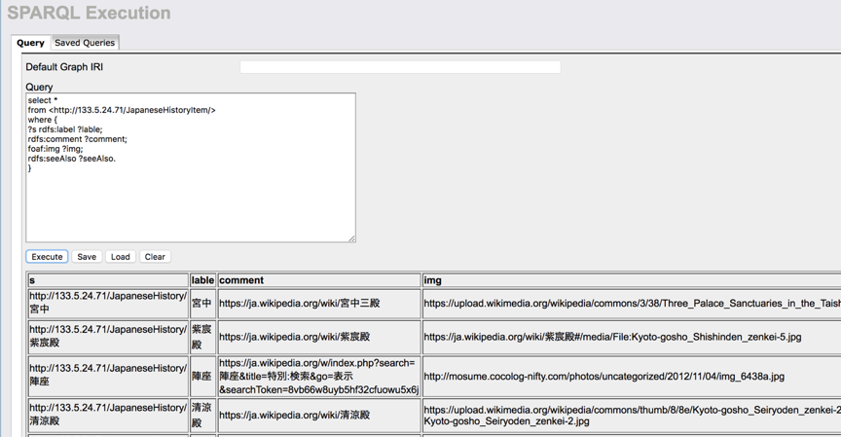

Figure 30: The implement of query for RDF data of Japanese history by SPARQL.

Finally, after acquiring the digital educational contents data based on linked data, the contents are able to be show and edit by utilizing the authoring tool. Fig.5.6 shows the screen image of complemented system of the authoring tool for Japanese history. By specifying a keyword ‘宮中’ ( One of Japanese history ) as the target of an educational material, the system retrieves text data, image data and video data related to the keyword from RDF stores and shows the multimedia information(Fig.31 and Fig.32).

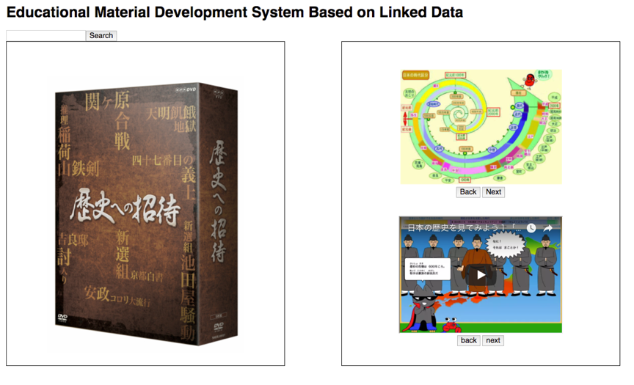

Figure 31: The implement of authoring tool for Japanese history.

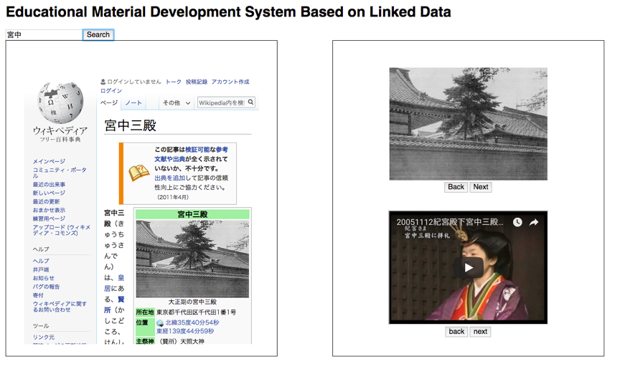

Figure 32: The implement of searching for Japanese history information.

The all above of processes is easy to be achieve for various sort of educational field. Therefore, the efficiency, convenience and versatility of the material development framework.

## 5.2 The discussion for capability of optimizing the materials basing on obtaining the feedback from students

Basing on the log data collected from web-viewer supporting learning analytics, the use of proposed visualization tool called Cubic Gantt Chart and Parallel Coordinates version of Time-tunnel for students’ e-learning activity data, mainly it becomes possible to understand the following three points.

1.How long and which pages students look at

2.How students transit among pages

3.Similar transit patterns of pages among students

From these points, with the use of integrated framework concluding authoring tool, web-viewer and visualization tools, teachers can grasp the students’ learning behaviors and editing the educational material basing the result of visualization. For example, users can learn about which pages that students spent much time. A teacher should spend more time for editing the corresponding contents. Then, the students will come to understand the contents more deeply and rapidly. As another example, if it could be found that many students go back to the previous pages to conform the contents related to the current page, a teacher should spend more time for building the relatedness of contents. Furthermore, if it could be found that there are several patterns of students’ transitions among pages, a teacher can divide contents into several classifications according to the patterns and then will be able to be learned by students with different learning style.

# Chapter6 Conclusion and Future work

In this article, we proposed an integrated educational material development framework based on linked data supporting learning analytics to support teachers to develop the educational material efficiently and conveniently.

Educational material contents database based on the Linked data was implemented. Through the establishment of data base based on linked data, a semantic data network has been constructed which is easily accessed and utilized by teachers when they are willing to search for educational materials distributed in the network.

In addition, educational material authoring tool based on linked data with Wikipedia, YouTube, image information as well was rebuilt. Thereby, teachers who are not familiar with computer science and programing skills are capable to develop multimedia educational materials with highly educational efficiency easily.

Furthermore, ePub format material development with pagination information for supporting learning analytics was realized. Meanwhile, the ePub format educational contents with multimedia will improve students learning motivation, efficiency competence.

Over and above, an ePub web-based educational material viewer supporting learning analytics was already been accomplished. Basing on visualizing the log data of reading activity collected from web-based viewer, the learning status of student are easily to be learn about and then, teachers are able to modify the educational material.

However, in the future work, there are two limitations of framework should be reflected. Given that I currently edit the ePub format book with pagination information manually, the ePub books which are able to support learning analytics are not capable to be created automatically. Therefore, for teachers are able to edit the educational material conveniently and automatically, an editing tool for ePub book included information which can be used for learning analytics bis supposed to be developed. In addition, not only the pagination information is looking forward to being included, but also more various learning activities information are able to be contained, such as notion, highlight, bookmark, session information and so on. It is my hope that the framework may in that way supporting a greater number of learning analytics by collecting educational big data, and be useful and convenient in educational material development.

# ACKNOWLEDGEMENT

I do owe numerous people during the course of my thesis work. I would like to take this opportunity to express my sincere appreciation to them. I would like to express my deepest gratitude to Pro. Yoshihiro Okada. He gave me infinite supports, encouragements, and inspiring advices all through my years as a master student, which were so valuable that without him, I would not have accomplished this dissertation.

There are so many people whom I feel obliged to express my sincere gratitude. It is most difficult to list all their names. I would like to extend my gratitude to the all of the faculty and staff in the Faculty of Arts and Science, Graduate School of Information Science and Electrical Engineering, the Kyushu University for the provision of the best equipment so that I could concentrate on my research.

# REFERENCE

[1] G. Ruiz J., J. Mintzer M., and M. Leipzig R., “The Impact of E- Learning in Medical Education,” Acad. Med., vol. 81, no. 3, pp. 207–212, 2006.

[2] D. T. Tempelaar, B. Rienties, and B. Giesbers, “In search for the most informative data for feedback generation: Learning analytics in a data-rich context,” Comput. Human Behav., vol. 47, pp. 157–167, 2015.

[3] H. Ogata, C. Yin, M. Oi, F. Okubo, A. Shimada, K. Kojima, and M. Yamada, “e-Book-based learning analytics in University education,” Dr. Student Consort. - Proc. 23rd Int. Conf. Comput. Educ. ICCE 2015, no. December, pp. 401–406, 2015.

[4] A. Brailas, K. Koskinas, M. Dafermos, and G. Alexias, “Wikipedia in Education: Acculturation and learning in virtual communities,” Learn. Cult. Soc. Interact., vol. 7, pp. 59–70, 2015.

[5] J. C. Green, T. Aziz, J. Joseph, A. Ravanam, S. Shahab, and L. Straus, “YouTube Enhanced Case Teaching in Health Management and Policy,” Heal. Prof. Educ., 2017.

[6] S. Li, L. Da Xu, and S. Zhao, “The internet of things: a survey,” Inf. Syst. Front., vol. 17, no. 2, pp. 243–259, 2015.

[7] https://cs.kyushu-u.ac.jp/sicorp/en/

[8] H. Takubo, “Educational Material Development System Based on Linked Open Data (in Japanese)”, Graduation thesis, Faculty of Science, Kyushu University, 2017.

[9] M. Chenguang, S. Kulshrestha, S. Wei, Y. Okada, and R. Bose, “E-Learning Material Development Framework Supporting VR / AR Based on Linked Data for IoT Security Education.”

[10] Ma Chenguang, Srishti Kulshrestha, Shi Wei, Yoshihiro Okada, Ranjan Bose, EDUCATIONAL MATERIAL DEVELOPMENT FRAMEWORK BASED ON LINKED DATA FOR IOT SECURITY, in iCERI 2017, 16-18, Nov., 2017.

[11] http://idpf.org/epub

[12] https://www.idpf.org/epub/linking/cfi/epub-cfi.html

[13] M. Chenguang, S. Kulshrestha, S. Wei, Y. Okada, and R. Bose, “LEARNING ANALYTICS FRAMEWORK FOR IOT SECURITY EDUCATION.”

[14] L. Atzori, A. Iera, G. Morabito, The internet of things: a survey, Comput. Netw. 54 (15) (2010) 2787–2805.

[15] D. Miorandi, S. Sicari, F. De Pellegrini, I. Chlamtac, Survey internet of things: vision, applications and research challenges, Ad Hoc Netw. 10 (7) (2012) 1497–1516.

[16] B. Emmerson, M2M: the internet of 50 billion devices, Huawei Win–Win Mag. J. (4) (2010) 19–22.

[17] L.A. Grieco, M.B. Alaya, T. Monteil, K.K. Drira, Architecting information centric ETSI-M2M systems, in: IEEE PerCom, 2014.

[18] R.H. Weber, Internet of things - new security and privacy challenges, Comput. Law Secur. Rev. 26 (1) (2010) 23–30.

[19] Tim Berners-Lee, “Design issues for the World Wide Web.Architectural” and “philosophical points,” http://www.w3.org DesignIssues/(1998).

[20] Christian Bizer, Tom Heath, and Tim Berners-Lee, “Linked Data -The Story So Far,” International Journal on Semantic Web and Information Systems (IJSWIS)(2009).

[21] Paul Miller, Sir Tim Berners-Lee, “Semantic web is open for business,” The Semantic Web(2008). URL http://blogs.zdnet.com/semantic-web/?p=105.

[22] D. Dicheva, “Ontologies and semantic web for e-Learning,” In Peter Bernus, Jacek Bła˙zewics, G¨unter Schmidt, Michael Shaw, Heimo H. Adelsberger, Kinshuk, Jan M. Pawlowski,and Demetrios G. Sampson, “Handbook on Information Technologies for Education and Training”, “International Handbooks on Information Systems”, Springer Berlin Heidelberg, pp. 47–65. (2008).

[23] E. I. Chong, S. Das, G. Eadon, and J. Srinivasan, “An Efficient SQL-based RDF Querying Scheme,” Proceedings of the 31st international conference on Very large data bases, VLDB Endowment Press, pp. 1216-1227,(2005).

[24] Y. H. Kim, B. G. Kim, J. Lee, and H. C. Lim, “The Path Index for Query Processing on RDF and RDF Schema,” Proceedings of the 7th International Conference on Advanced Communication Technology (ICACT) , IEEE, Jul 2005, pp. 1237-1240,(2005).

[25] B. Quilitz, U. Leser, “Querying Distributed RDF Data Sources with SPARQL, the Semantic Web: Research and Applications,” Springer Berlin Heidelberg, pp. 524-538, (2008).

[26] https://www.w3.org/TR/2000/CR-rdf-schema-20000327/

[27] https://www.w3.org/TR/2000/CR-rdf-schema-20000327/

[28] https://github.com/futurepress/epub.js/

[29] West, Darrell M. “Big data for education: Data mining, data analytics, and web dashboards.” Governance Studies at Brookings(2012): 1-10.

[30] Yamada, Masanori, et al. "Preliminary Research on Self-regulated Learning and Learning Logs in a Ubiquitous Learning Environment."

[31] Ogata, H., Li, M., Bin, H., Uosaki, N., El-Bishouty, M. M., & Yano, Y. (2010). Ubiquitous Learning Log: What if we can log our ubiquitous learning? Proceedings of the 18th International Conference on Computers in Education (pp. 360-367).

[32] http://www.ivansinsurance.com/en-us/for-insurers/resources/webinars/what-is-bookroll/

[33] Picciano, Anthony G. “Ther Evolution of Big Data and Learning Analytics in American Higher Education.” Journal of Asynchrous Learning Networks 16.3 (2013) : 9-20

[34] Klemm, Paul, et al. "Interactive visual analysis of image-centric cohort study data." Visualization and Computer Graphics, IEEE Transactions on 20.12 (2014): 1673-1682.

[35] Nakamura, S. and Okada, Y. : Learning Analytics Using BookLooper and Time-tunnel, INTED 2017, pp. 8767-8776.

[36] Nakamura, S., Kaneko, K., Okada, Y., Yin, C. and Ogata, H. : Cubic Gantt Chart as Visualization Tool for Learning Activity Data, The 1st workshop on e-Book-based Educational Big Data for Enhancing Teaching and Learning of ICCE2015, pp. 649-658.

[37] Herman, Ivan, Guy Melançon, and M. Scott Marshall. "Graph visualization and navigation in information visualization: A survey." Visualization and Computer Graphics, IEEE Transactionson 6.1 (2000): 24-43.

[38] A. Inselberg and B. Bimsdale, “Parallel Coordinates: A Tool for visualizing Multidimensional Geometry.” Proc. IEEE Visualization 1990, IEEE CS Press, pp 361-378, 1990

[39] James M. Wilson. “Gantt charts: A centenary appreciation” European Journal of OperationalResearch 149 (2003) 430-437

[40] Aigner, Wolfgang, et al. "Visual methods for analyzing time-oriented data." Visualization and Computer Graphics, IEEE Transactions on 14.1 (2008): 47-60.